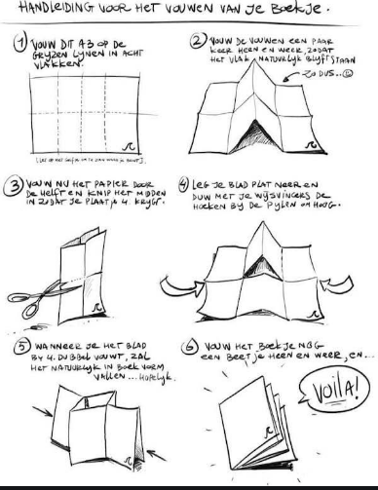

**A4**

**PELGRIMS**